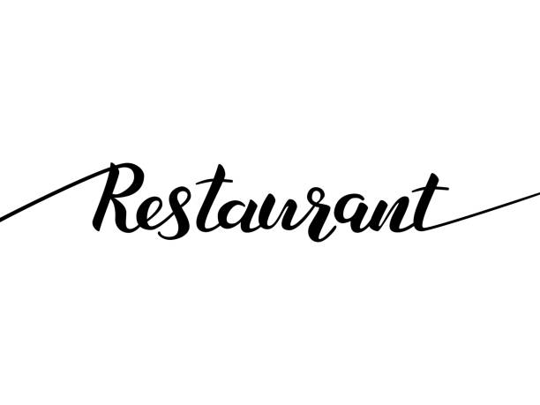
Restaurant Project
Mick Verboven
TIA4v1a

Inhoudsopgave

Inhoud

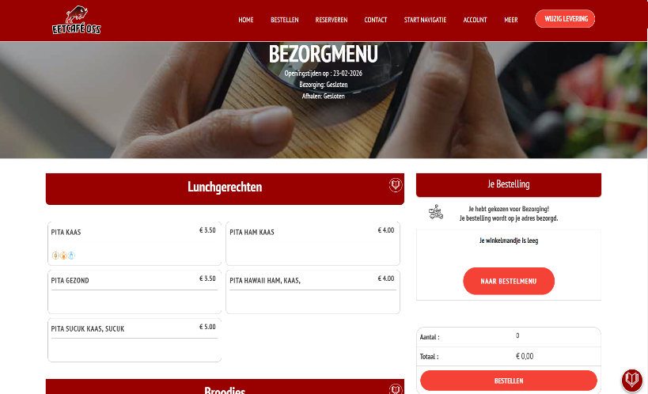
Inspiration

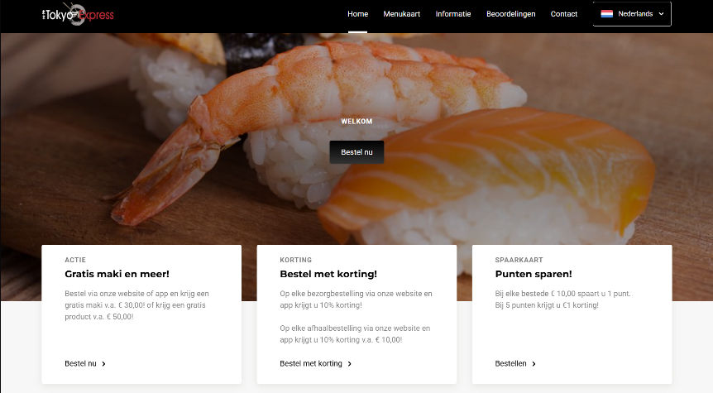
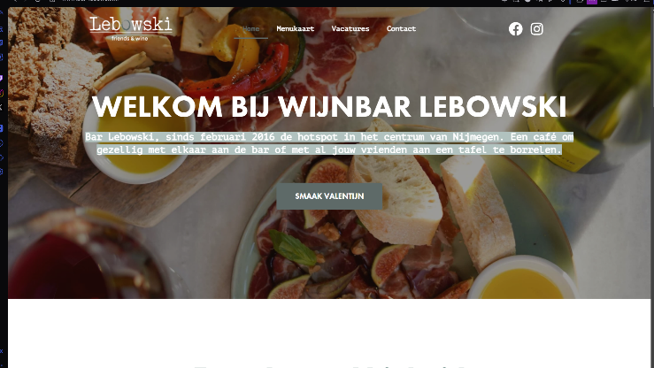

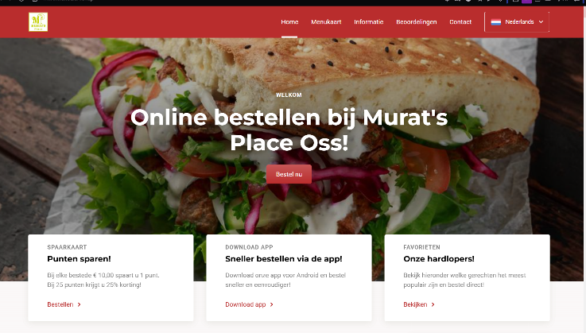
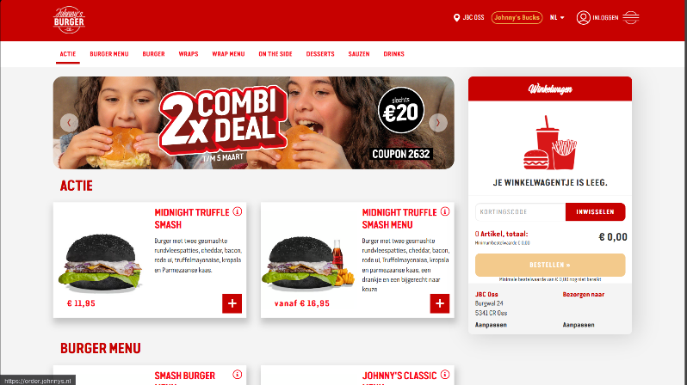

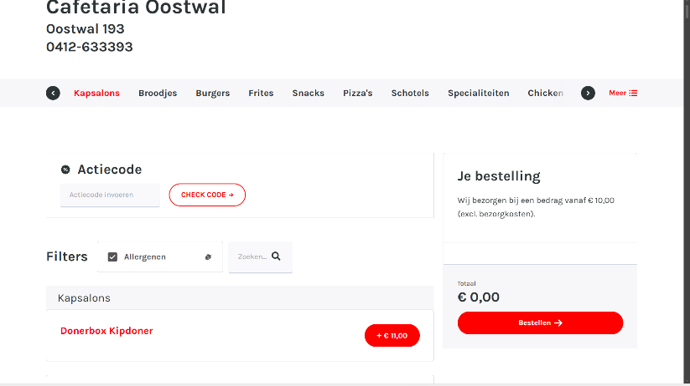

HouseStyle
Colors
Primary | #1A1A1A
Secondary | #2E2E2E
Accent | #C9A84C
Border/Muted | #9A7A2E
Primary Text | #F2EDE4
Secondary Text | #C4BDB2

Tekst Style:
Bebas Neue | Cormorant Garamond | DM Sans

Wireframes

